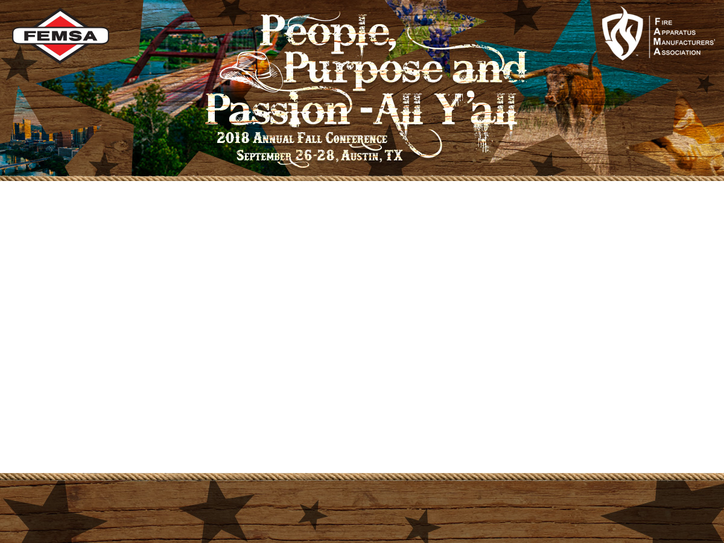

**Link to Videos Shown during the Carcinogen Particulate Presentation by the**

**Coral Springs, Florida Fire Department on 9-26-18**

<https://www.dropbox.com/sh/3uqpeelqu1akcxn/AADEqBxMZ-dWxRVj7uKwH3_ta?dl=0>