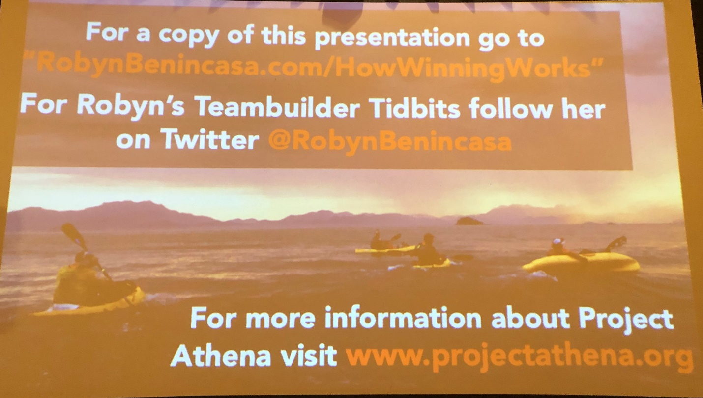

Robyn Benincasa Presentation File: www.projectathena.org

