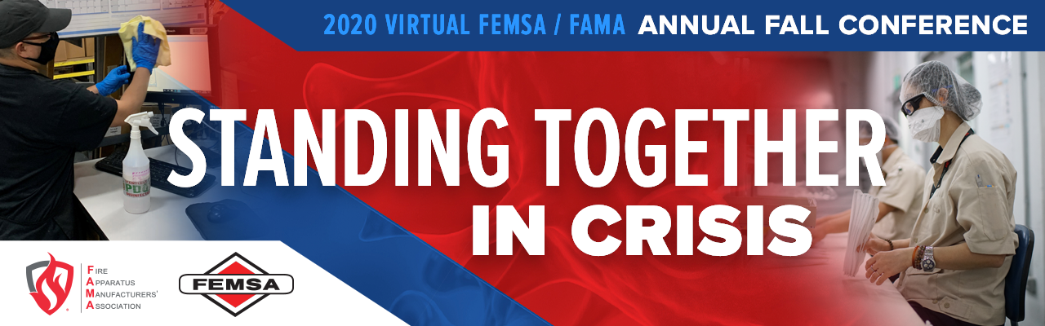

FAMA 2020 Fall Business Meeting Video

Weblink:
https://www.dropbox.com/sh/vf84hk14q6u6x7x/AAAqytRkw1JMaIwQnC6Pc_nJa?dl=0

Password: FAMAMemMtg10062020

FAMA CONFIDENTIALITY STATEMENT

IT IS EXPRESSLY UNDERSTOOD AND AGREED BY THE RECIPIENT THAT THIS DOCUMENT WILL BE USED FOR THE RECIPIENT’S INTERNAL PURPOSES ONLY AND SHALL NOT BE REFERENCED, CITED OR IN ANY WAY USED IN ANY ADVERTISEMENTS OR OTHER MATERIALS FOR THE MARKETING OR PROMOTION OF THE RECIPENT’S PRODUCTS. BY ACCEPTING THIS REPORT, THE RECIPIENT AGREES TO ABIDE BY THESE CONDITIONS.

© Fire Apparatus Manufacturers' Association (FAMA) 2020 Note: All FAMA documents and materials are the copyrighted property of the Fire Apparatus Manufacturers' Association, which are exclusively licensed to FAMA member companies for their internal use only. Any distribution, sharing or other dissemination of FAMA documents and materials, except for internal use by FAMA member companies, is strictly prohibited without the express written consent of the Fire Apparatus Manufacturers' Association.

